Alexandria university

Faculty of computers and data science

RRPM department website

**System design and architecture**

# Table of Contents

Table of Contents 2

Revision history 3

Document approval 3

1. Introduction 4

1.1. Purpose 4

1.2. Scope 4

1.2.1. Product Identification 4

1.2.2. Product Capabilities 4

1.2.3. Application, Benefits, and Objectives 4

2. System Overview 5

2.1. System Description 5

2.2. Key features 5

2.3. Stakeholders 5

3. System architecture 6

3.1. Architecture diagram 6

3.2. Components Overview: 7

4. Detailed design 8

4.1. Database Design 8

4.1.1. Conceptual Entity-Relationship Diagram (ERD) 8

4.1.2. Logical Data model 10

# 

# Revision history

| **Date** | **Description** | **Author(s)** | **Comments** |
| --- | --- | --- | --- |
| 3/12/2024 | Version 1 | * Ghada Essam * Lina Essam | - |
|  |  |  |  |
|  |  |  |  |
|  |  |  |  |

# Document approval

The following System design and architecture report has been accepted and approved by the following:

| **Status** |  |
| --- | --- |
| **Author(s)** |  |
| **Approver** |  |
| **Document type** |  |
| **Version** |  |
| **Release Date** |  |

# Introduction

## Purpose

The purpose of this document is to provide an overview of the system design and architecture for the RRPM department website. This includes a description of the system architecture, its components, and the database design.

The medical center website is designed to serve general users (patients) by providing information about the units, clinics, and activities. It also includes a collection of medical research articles that users can read.

## Scope

### Product Identification

The Rheumatology, Rehabilitation, and Physical Medicine (RRPM) Department Website aims to provide accurate information about rheumatology and physical health, raise public awareness, and connect patients with specialized medical units.

### Product Capabilities

* General Users:  
  Access information about the department, medical units (clinics, services, activities), organized events, scientific research, and contact details.
* Admin Users:  
  Manage the website content with tools for creating, reading, updating, and deleting information related to medical units, activities, research, and contact details.

### Application, Benefits, and Objectives

* Provide detailed medical unit information to help users locate services and clinics.
* Enhance public awareness about rheumatology, rehabilitation, and physical health.
* Empower admins with efficient content management tools.
* Offer reliable contact options for users to connect with the department and its units.

# System Overview

## System Description

The Rheumatology, Rehabilitation, and Physical Medicine (RRPM) Department Website is an online platform designed to provide accessible, reliable, and organized information about the department's units, services, and activities. It aims to serve two primary user groups:

1. General Users (Patients):
   * They can explore detailed information about the department, including individual medical units, clinics, available services, and scheduled activities.
   * The website also features a section for scientific research articles and department-related events, contributing to public health awareness and education.
2. Admin Users:
   * Admins are responsible for maintaining the website's content. They can manage (add, update, delete) all information displayed, including unit details, activities, research articles, and contact information.

The system's architecture ensures a user-friendly interface for visitors and efficient management tools for administrators. It supports secure access, providing general users with read-only access to public content and admin users with role-based control over content management.

By bridging the gap between patients and specialized medical care, the system promotes public awareness, efficient communication, and ease of access to the department’s resources.

## Key features

* Display information about units and clinics
* Display the activities organized by the units or the general department
* Display a collection of scientific research articles
* Display contact information for each unit
* Admin panel for managing content.

## Stakeholders

1. General users

Visitors to the website, including patients and the general public.

1. Administrators

Website admins responsible for managing and maintaining content.

# System architecture

## Architecture diagram

## Components Overview:

## 

## 

## Database Design

### Conceptual Entity-Relationship Diagram (ERD)

* **Purpose:**
* Provides a high-level, conceptual representation of the system's entities and relationships.
* Focuses on the logical structure of the database, showing how entities relate to one another.
* **Key Components:**
* Entities: Represented as rectangles (e.g., *Clinic*, *Service*, *Unit*).
* Relationships: Represented as diamonds (e.g., *contains*, *provides*, *organizes*).
* Cardinality: The lines connecting entities may have notation to indicate the cardinality of relationships (e.g., one-to-many, many-to-many).
* Representation: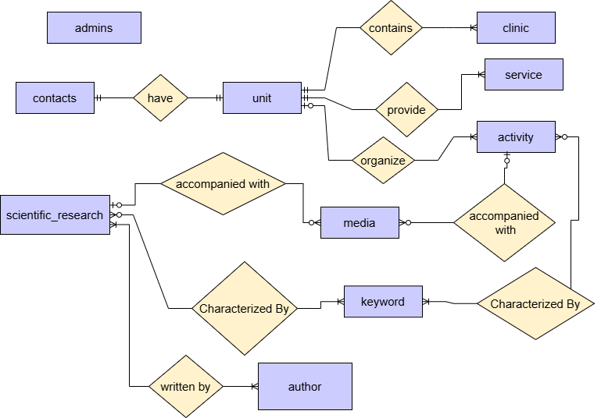
* **Description:**
* **Admins:** represents system administrators, storing information for authentication, including username and password
* **Unit:** an entity that contains information about each unit
  + Each unit provides one or more service
  + Each unit contains one or more clinic
  + A unit may organize zero or more activity
  + Each unit have its contact information
* **Clinic:** an entity that contains information about clinics of unit
  + A clinic is a part of one unit
* **Service :** an entity that describes a service provided by a unit
  + A service is provided by one or more unit
* **Activity:** an entity that contains information about the activities of a unit or an activity by the general department
  + An activity may be organized by one unit or directly by the general department.
  + An activity may be accompanied by zero or more media elements
  + An activity must be characterized by one or more keywords
* **scientific_research:** an entity that contains the data of each scientific research article
  + Each scientific research must be written by **one or more authors**.
  + Each scientific research may be accompanied by with zero or more media element
  + Each scientific research must be characterized by a certain keyword
* **media:** an entity that contains all the media elements displayed in activities or in the scientific research articles
  + A media element must be assigned to exactly one scientific research or one activity.
* **keyword**: an entity that contains all keywords that characterizes an activity or a scientific research to be used in search
  + A keyword can be associated with one or more activities and one or more scientific research articles
* **author:** an entity which contains information about authors who have written a scientific research
  + an author can write one or more scientific research

### Logical Data model

* **Purpose:**
* Represents the physical database structure with normalized tables.
* Focuses on the implementation details required for development.
* **Key Components:**
* Tables: Each entity from the ERD is converted into a table (e.g., *Unit*, *Clinic*, *Activity*).
* Columns: Define the attributes of each entity with data types (e.g., INT, VARCHAR(255), DATE).
* Primary Keys (PK): Unique identifiers for each row in a table.
* Foreign Keys (FK): Relationships between tables, where one table references the primary key of another table.
* **Representation:**A close-up of a computer screen

  Description automatically generated
* **Description:**

1. **Admins**:
   * Contains credentials for admin users (e.g., username and password_hash), used for authentication and authorization.
2. **Unit**:
   * Represents organizational divisions within the department. Each unit (unit_id) includes attributes like name, address, working_hours_start, working_hours_end, and phone_number.
   * A unit may organize one or more **Activities**, contain one or more **Clinics**, and offer one or more **Services** (via a many-to-many relationship through service_unit).
3. **Clinic**:
   * Represents the clinics under each unit. A clinic (clinic_id) has a name (clinic_name) and is associated with one unit (unit_id).
4. **Service**:
   * Represents services offered by the medical center. Services (service_id) can be linked to one or more units through the service_unit relationship table.
5. **Activity**:
   * Represents events or programs organized by a unit or the general department. Attributes include title, date, time, location, status, summary, and description.
   * Activities may involve **Media** (e.g., images or videos) and be associated with one or more **Keywords** through the keywords_activity table.
6. **Scientific Research**:
   * Represents scientific research articles authored by individuals. Each research (SR_id) includes attributes such as title, publishing_date, and content.
   * Research can have multiple **Authors** and be linked to one or more **Keywords** via keywords_SR.
7. **Author**:
   * Represents individuals who have authored scientific research. Each author (author_id) is associated with one or more research articles (SR_id).
8. **Media**:
   * Stores media elements such as images or videos linked to either an **Activity** or **Scientific Research** through foreign keys (activity_id and SR_id).
9. **Keywords**:
   * Represents tags used to categorize or search for **Activities** and **Scientific Research**. Keywords (keyword_id) are linked to both entities through their respective relationship tables: keywords_activity and keywords_SR.

**Key Relationships:**

* **Unit and Activity**: A unit (unit_id) organizes zero or more activities (activity_id).
* **Unit and Clinic**: Each unit (unit_id) contains one or more clinics (clinic_id).
* **Unit and Service**: A unit (unit_id) offers one or more services through a many-to-many relationship with the service_unit table.
* **Activity and Media**: Each activity (activity_id) can involve one or more media elements (media_id).
* **Scientific Research and Author**: Each scientific research article (SR_id) can have one or more authors (author_id).
* **Keywords**: Keywords (keyword_id) are linked to both activities (activity_id) and scientific research articles (SR_id) via separate many-to-many relationship tables.

# 